CubeSats Case Study

IIT Kanpur’s Jugnu

OBJECTIVE:

Develop a Nano Satellite at [IIT Kanpur](https://en.wikipedia.org/wiki/Indian_Institute_of_Technology_Kanpur) that can be used as Micro Imaging Systems, GPS receiver for locating the position of satellite in the orbit and MEMS* based Inertial Measurement Unit(IMU).It provided data for agriculture and disaster monitoring

* Cost: 2.5 crores
* Weight: 3-kilogram (6.6 lb)
* Dimension: 13in x 3.9in x 3.9in (cuboidal)
* Launch vehicle: PSLV-CA

Image:

*MEMS: (micro-electromechanical system) is a miniature machine that has both mechanical and electronic components. The physical dimension of a MEMS can range from several millimeters to less than one [micrometer](https://whatis.techtarget.com/definition/micrometer), a dimension many times smaller than the width of a human hair

**ADCS**

The Attitude Determination and Control System (ADCS) orients the satellite in a manner such that maximum solar energy is incident on its solar panels. During imaging the satellite must point at a fixed location on earth in order to capture high-quality images, which is accomplished by the ADCS. It also ensures that the narrow beam antenna is directed in the right direction 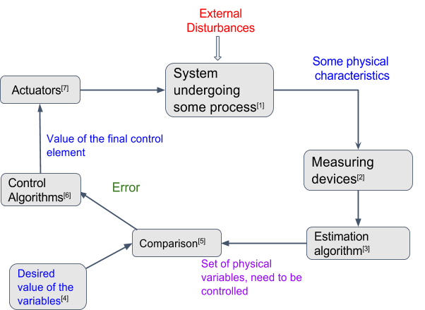

Actuators use control systems like PID controller The small satellite faces very stringent power and mass constraints. Thus, sensors which consume lot of power for operation can not be used continuously.

**Thermal**

The Thermal Control Subsystem(TCS) maintains the temperature within the specified limit of 298K to 323K. It ensures that no large thermal gradients and no excessive thermal stress across the structures occur. The Thermal control subsystem of JUGNU is essentially passive with [MLI](https://en.wikipedia.org/wiki/Multi-layer_insulation) sheets, [OSR](https://en.wikipedia.org/wiki/Optical_solar_reflector) and surface coatings as key components. It also has IC and [thermocouple](https://en.wikipedia.org/wiki/Thermocouple) based sensors to provide for the feedback and maintain the health of sensitive IC's and Camera. The heat that is produced at the chip level is rapidly distributed to the system to prevent it from getting damaged.

**Imaging:**

This Subsystem captures [near IR](https://en.wikipedia.org/wiki/Near_infrared) images of targeted surface on earth which helps in identification of the utilization of the place. The subsystem consists of a "Near IR camera", an external storage and an On-Board Computer(OBC) which acts as an interface between the two, apart carrying out the image compression/processing. The camera captures a 640X480 px image which is then transferred to an external memory by the OBC. The image is then processed (if required) and transmitted to the ground station. An overall resolution of about 161 X 161 *m2* per pixel is expected on earth's surface. The total area of view, on earth's surface is expected to be around 103 X 77 *km2*.

**RTOS:** A **real-time operating system** (**RTOS**): RTOS is a special type of operating system that has very small processing delay Processing must be done within the defined constraints or the system will fail. They usually use pre-emptive task scheduling which is basically high priority first scheduling. Processing must be done within the defined constraints or the system will fail.